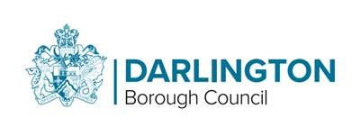

Busking Application Form

You can apply for your busking permit badge by completing the form. Any questions please contact the Events Team in person (Mon - Fri 9am to 5pm) at the Dolphin Centre or contact: the Events Team, Dolphin Centre, Horsemarket, Darlington, DL1 5RP, 01325 388438 / 388151 / 388247.

Full Name of Applicant
(State Mr/Mrs/Miss/Ms)

Home Address of Applicant including postcode

E-Mail Address
(If applicable)

Home  Telephone |  | Business Telephone |  | Date of Birth

General description of Act/performance/
entertainment

Do you use amplification | Yes |  | No

Do you have any form of viewing your act/performance/
entertainment i.e. You Tube, My space? If so please provide information

Please note: Once you have signed the license agreement, you will receive a yearly membership badge which you must wear at all time whilst performing in the town.
Where possible, please inform the Events Team of your intentions to performing in the town centre.

I certify that the above details are to the best of my knowledge a true and correct record.

Signature of Applicant |  | Date

For Office Use only
Application authorized by |  | Badge No Issued

Comments/Remarks

Signed |  | Date

