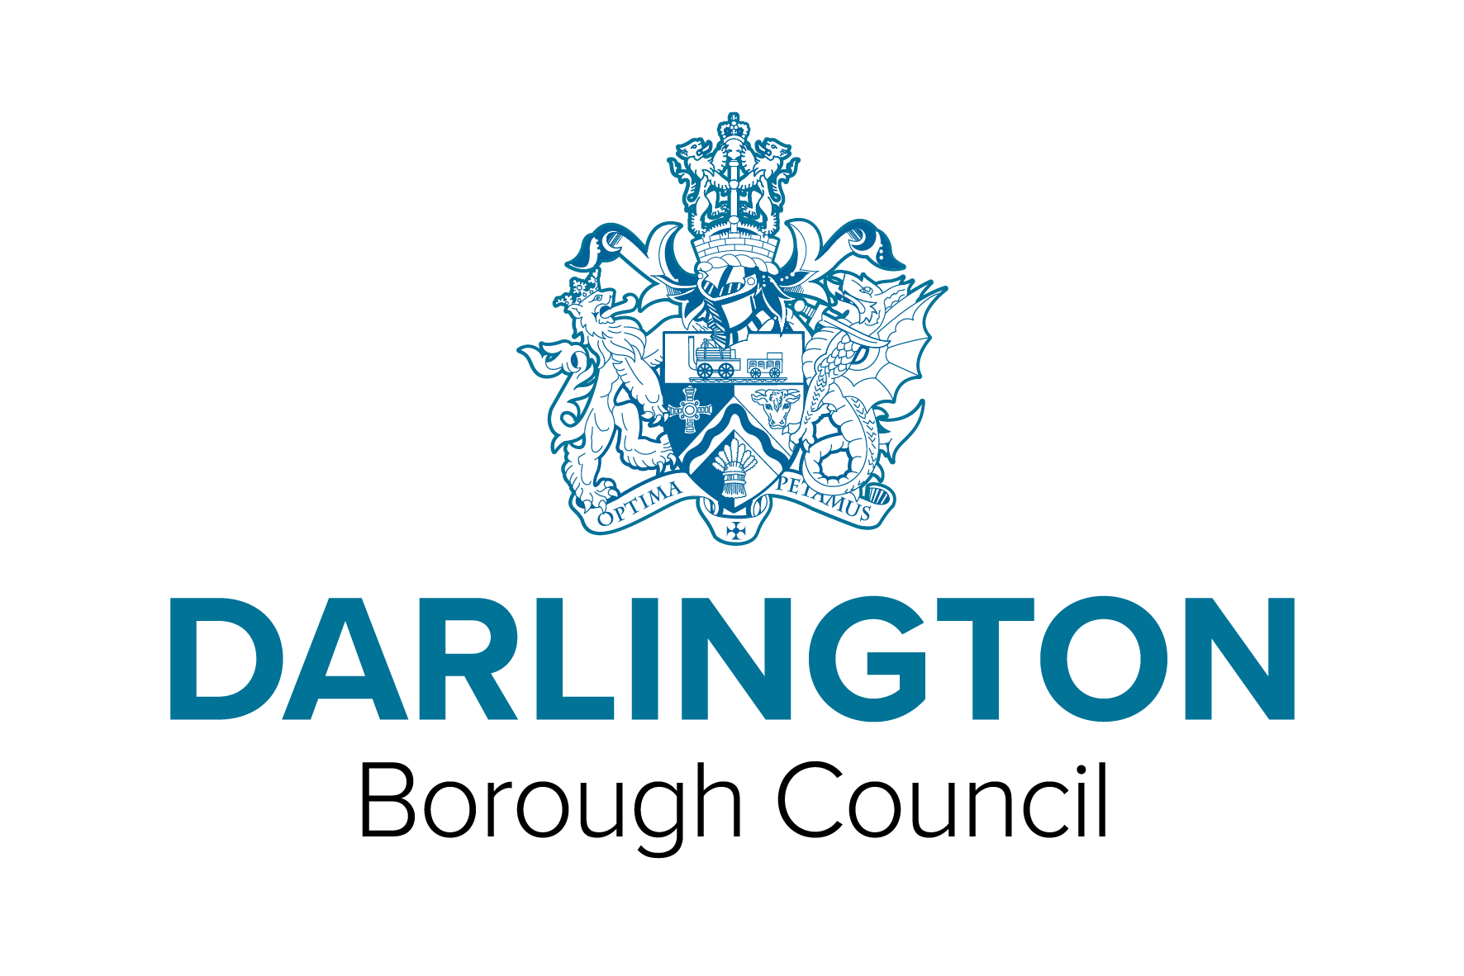Application For Renewal Of A Zoo Licence Zoo Licensing Act 1981

I hereby apply to Darlington Borough Council (being the Local Authority for the area within which the whole or major part of the zoo is to be situated) for renewal of a licence to operate the zoo referred to below to exhibit the kinds of animals as listed in the taxonomic category of order below.

Applicant Details
Mr |  | Mrs |  | Miss |  | Ms |  | (Please Tick)
Surname

First Name

Middle Name(s)

Address:

Postcode:

Date of Birth:

Mobile Number:

Telephone Number:

E-Mail Address:

Premise Details
Address of Premises to be Licensed:

Postcode

Trading Name:

Telephone Number:

Email Address:

Existing Licence Number:
Expiry Date of Licence:

Taxonomic category of order and approximate number in each group
(Note - as an alternative to listing on this form a proposed stock list may be attached)

Please read carefully the statement below before signing this application;

 How We Collect And Use Information
The information collected, on this form and from supporting evidence, by Darlington Borough Council will be used to process your application. The information may be passed to the Department of Social Security, Employment Service and Inland Revenue and such other Departments of the Council and external organisations but only if the law permits us to do so.
We may check information provided by you, or information about you provided by a third party, with other information held by us. We may also get information from certain third parties, or give information to them to check the accuracy of information, to prevent or detect crime, or to protect public funds in other ways, as permitted by law. These third parties include Government Departments and local authorities. Darlington Borough Council is the Data Controller for the purposes of the Data Protection Act 1998. If you want to know more about what information we have about you, or the way we use your information, please contact us at the address overleaf.

Signed |  | Date

When completed, please return this form together with the required fee to either:-

- In Person to the Licensing Office, Darlington Borough Council; or by post to:

- Licensing, Darlington Borough Council Feethams, Darlington, DL1 5QT together with the appropriate fee

Payment can be made in the following way
IN PERSON
Make your payment at the Licensing Department located at Darlington Borough Council. Please ensure that you produce all the required paperwork
BY PHONE 01325 405888
Make your payment using your debit or credit card once your application has been submitted. Please ensure that you quote the name of your premise and type of application when making your payment.
BY BACS TRANSFER
Please ensure that you quote the invoice number, the amount to pay, the date of payment and the Councils Bank Details

Account Name: Darlington Borough Council
Account No: 034640868
Sort Code: 30-84-43
Bank Address: Lloyds Bank

